Soul Cakes: Every cake eaten would represent a soul freed from Purgatory. The giving and receiving of soul cakes started in the Middle Ages and is widely seen as the origin of trick or treating.
Ingredients:
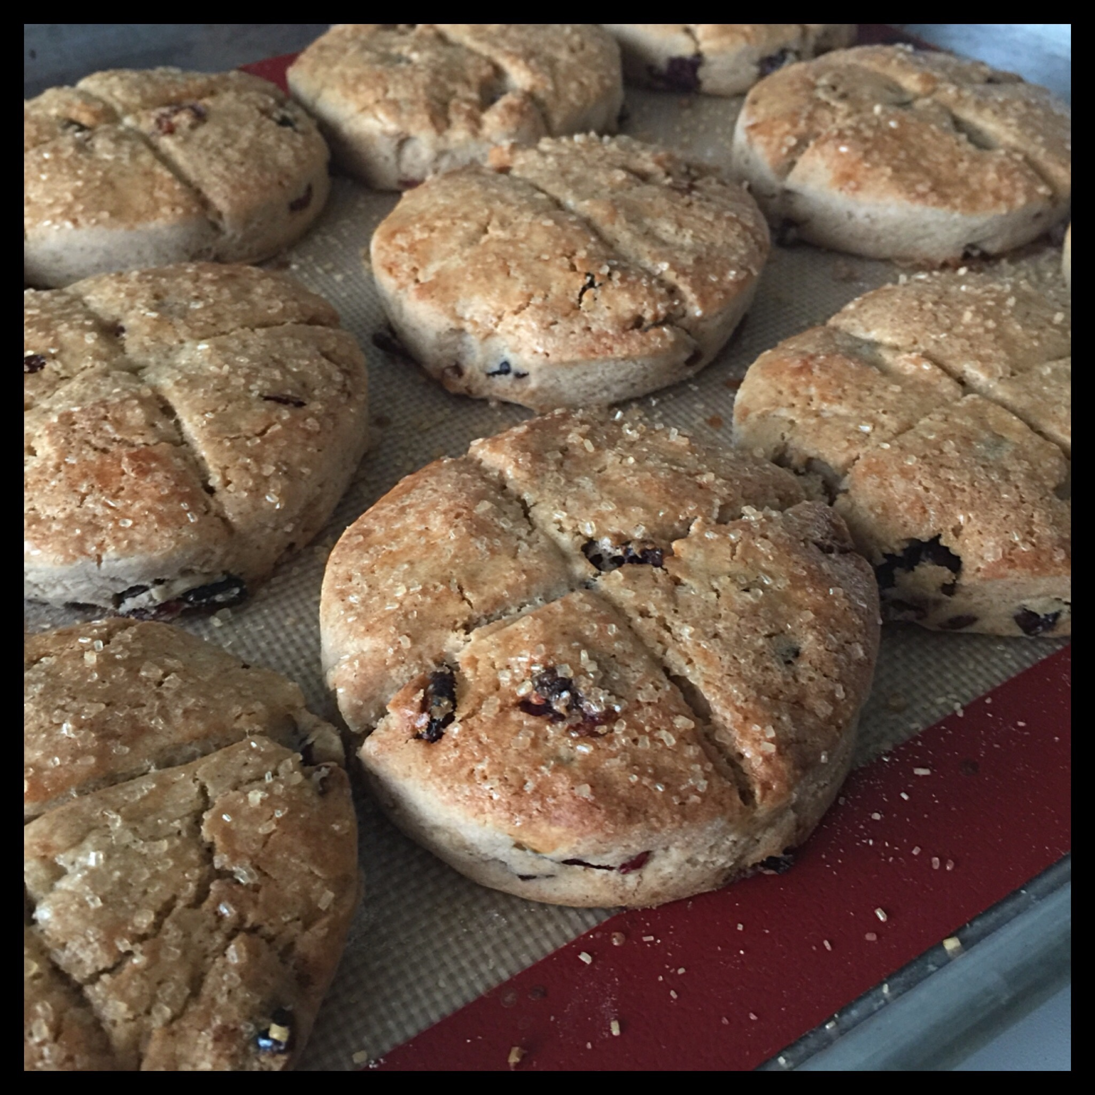
- 2 cups all-purpose flour
- 1/2 teaspoon nutmeg, ground fresh if possible
- 1/2 teaspoon cinnamon, ground fresh if possible
- 1/2 teaspoon salt
- Generous pinch of saffron
- 1/2 cup milk
- 1 stick (8 tablespoons) unsalted butter, softened
- 1/2 cup sugar
- 2 egg yolks
- 1/2 cup currants/golden raisins/raisins
For the Glaze:
- 1 egg yolk, beaten
Directions:
- Preheat oven to 400 degrees.
- Combine the flour, the nutmeg, cinnamon, and salt in a small bowl. Mix well with a fork.
- Crumble the saffron threads into a small saucepan and heat over low heat just until they become aromatic, taking care not to burn them. Add the milk and heat just until hot to the touch. The milk will have turned a bright yellow. Remove from heat.
- Cream the butter and sugar together in a medium bowl with a wooden spoon (or use an electric mixer with the paddle attachment). Add the egg yolks and blend in thoroughly with the back of the spoon. Add the spiced flour and combine as thoroughly as possible; the mixture will be dry and crumbly.
- One tablespoon at a time, begin adding in the warm saffron milk, blending vigorously with the spoon. When you have a soft dough, stop adding milk; you probably won't need the entire half-cup.
- Add the currants/golden raisins/raisins
- Turn the dough out onto a floured counter and knead gently, with floured hands, until the dough is uniform. Roll out gently to a thickness of 1/2 inch. Using a floured 2-inch round cookie or biscuit cutter, cut out as many rounds as you can and set on an ungreased baking sheet. You can gather and re-roll the scraps, gently.
- Score the soul cakes with with a knife in a cross or “X” pattern betwee 1/8 to 1/4 inch deep. Brush liberally with the beaten egg yolk. Sprinkle with coarse sugar or wait until baked and sprinkle with confectioners sugar.
- Bake for 15 minutes, until just golden and shiny. Serve warm.

