Irish Halloween barmbrack recipe
Ingredients:
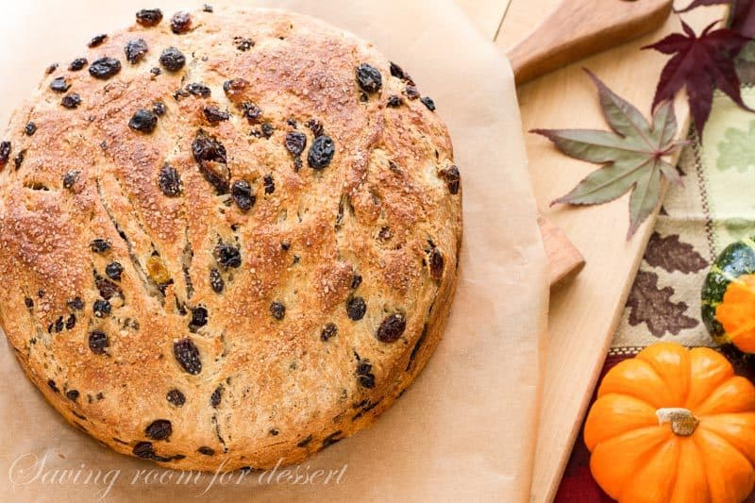
- 3 1/2 cups plain flour (450g)
- 1/2 tsp ground cinnamon
- 1/2 tsp ground nutmeg
- 2 teaspoons (1 sachet) dried yeast (7g)
- 4 tablespoons butter (75g)
- 1/3 cup castor sugar (75g)
- 1 cup milk (250ml)
- 1 beaten egg
- 1 cup raisins (150g)
- 3/4 cup currants (100g)
- 1/4 cup chopped dried fruit peel (50g)
- Some melted butter for greasing
Method:
- Warm the milk, add the butter, and let it melt in the warm milk.
- Mix the yeast with 1 tablespoon of sugar. Add half the warmed milk mixture. Add the beaten egg.
- Sift the cinnamon with the flour into a bowl. Make a well in the center and pour the yeast and liquid mixture into it. Sprinkle a little flour over the liquid and leave it in a warm place for 20 minutes until the yeast froths up.
- Add in the remainder of the liquid and mix the whole lot into a dough. Turn it out onto a floured board, sprinkle with the sugar, raisins, currants, and chopped peel, and knead them into the dough. Place a penny in the cake, as this meant you were going to be rich. Other items buried in the barmbrack are a ring for the bride-to-be, a thimble for the one who would never marry, and a small piece of cloth indicating the one who would be poor. Make sure the item as clean ;-)
- Put the dough into a butter-greased large bowl, cover with cling wrap and leave in a warm place until doubled in size.
- Knead it back again and then shape into your greased bread tin. Brush the top with melted butter and cover until doubled in bulk again.
- Bake for 40 minutes in a pre-heated hot oven at 400°F (200°C /Gas mark 6) until a skewer inserted into the center comes out clean.
- To give it a nice glaze, stir 1 tablespoon sugar into 2 fl oz boiling water (50ml) and brush this over the top of the loaf when it comes out of the oven and is still hot. Leave to cool before cutting.

