Intro to the Internet for the Average SCAdian
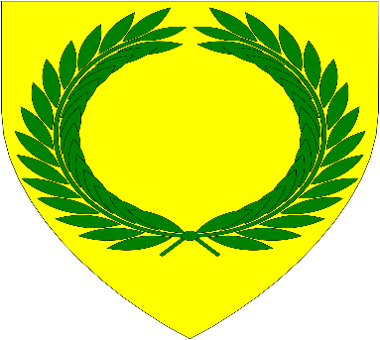
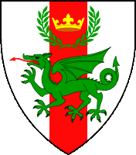
This Photo by Unknown Author is licensed under CC BY-SA

Baintighearn Deirdre MakKynneth
Social Media Officer for Barony of Brendoken
and Marche of Alderford
Selene_m_crow@yahoo.com
FACEBOOK, a necessary evil?

In a nutshell? Yes.
- Event Updates
- Demos
- Meetings
- New friend from war, RUM, TOA, etc.

NOT a requirement!
- Email Lists
- Meetings
- Phones
- Snail Mail List

Groups/Pages to follow (yes! They are different):
- Barony of Brendoken, Barony of Cleftlands
- Marche of Alderford, Gwyntarian, Thistle, Three Towers
- North Oaken
- SCA Kingdom of the Middle
- Respective offices or interests (thrown weapons, A&S, Page School, marshals, etc.)

YouTube Pinterest Discord

Youtube and Pinterest can be accessed by anyone without having to create a login or account, HOWEVER, returning to things you’ve previously viewed is incredibly challenging.
YouTube contains channels which host videos, Brendoken and Alderford both have YouTube channels, as well as Midrealm RUM and several populace members.
Pinterest is a virtual version of pinning cutouts from a magazine onto a cork board. You can view other “boards” or create your own. Brendoken and Alderford both have accounts here as well.
Discord is the new kid on the block, and you will need a login. It’s similar to 90s chat rooms and BBS servers. You have the main “Server” (Brendoken and Midrealm both have one, as do the Brendoken Blades) and each server has channels that essentially serve as the topic for each “chat room”

MIDREALM.ORG- Submitting A&S, award recommendations and officer reports
Computer Mobile
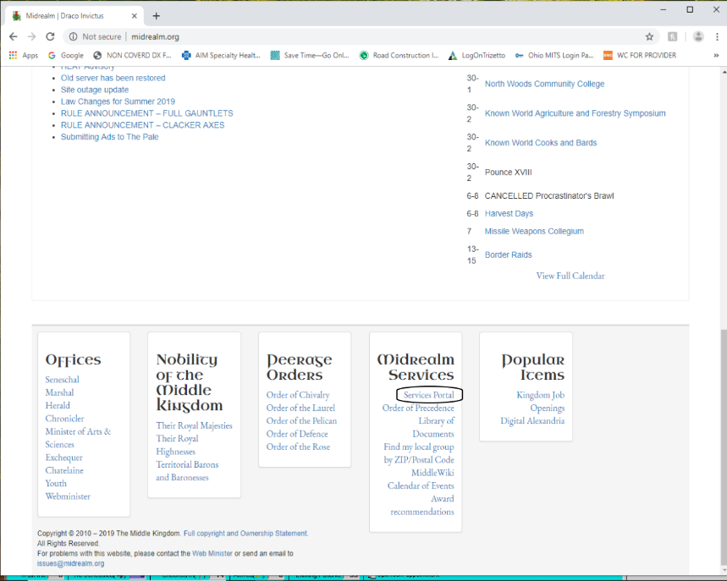 | 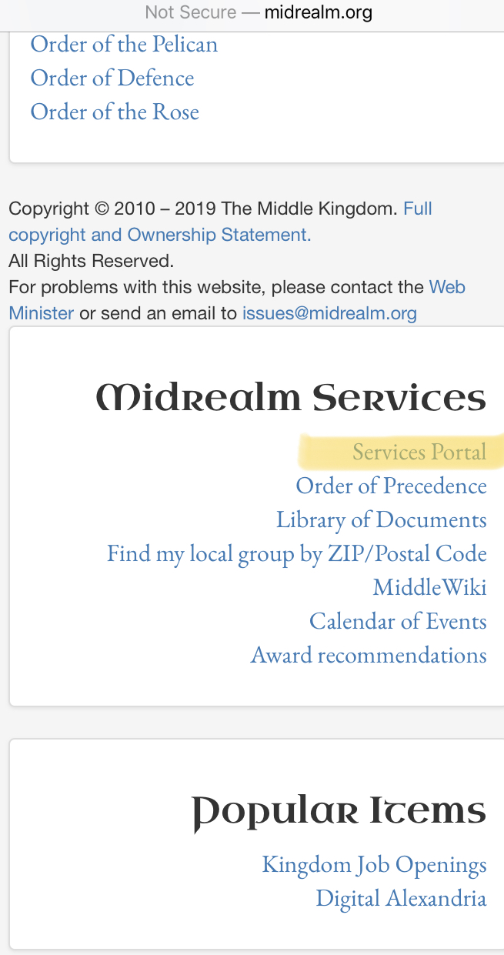
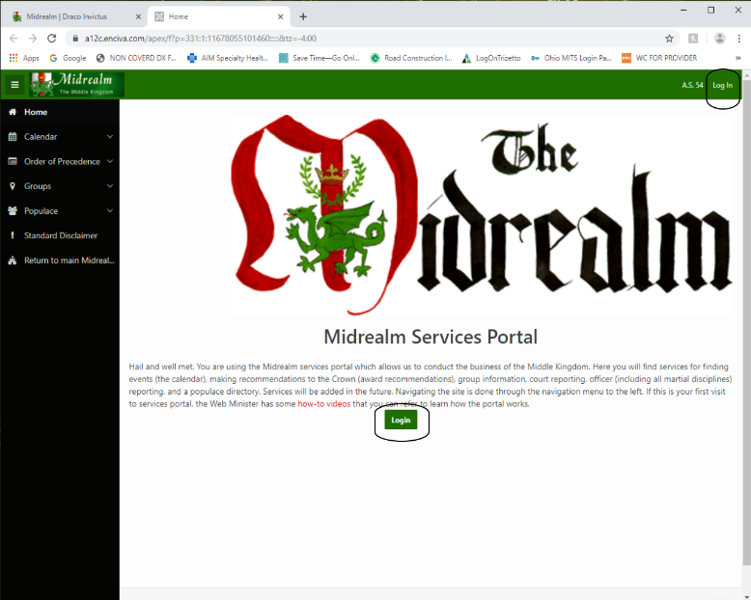 | 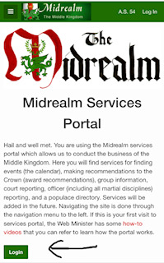
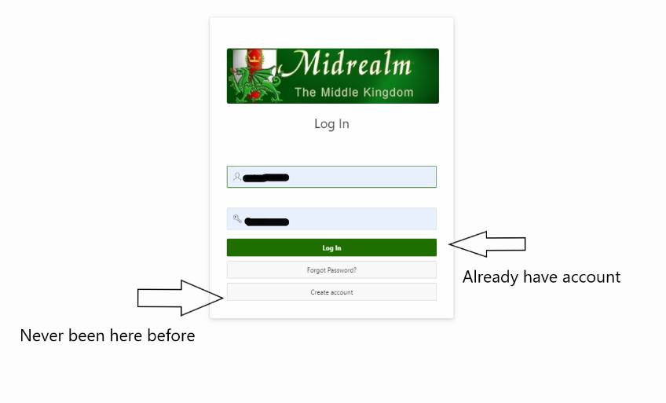 | 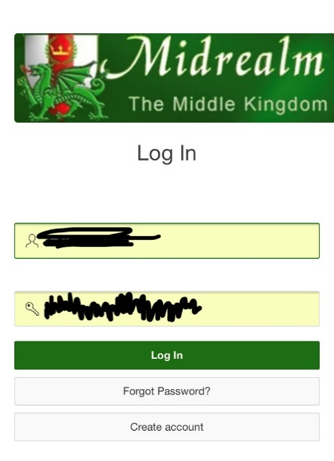
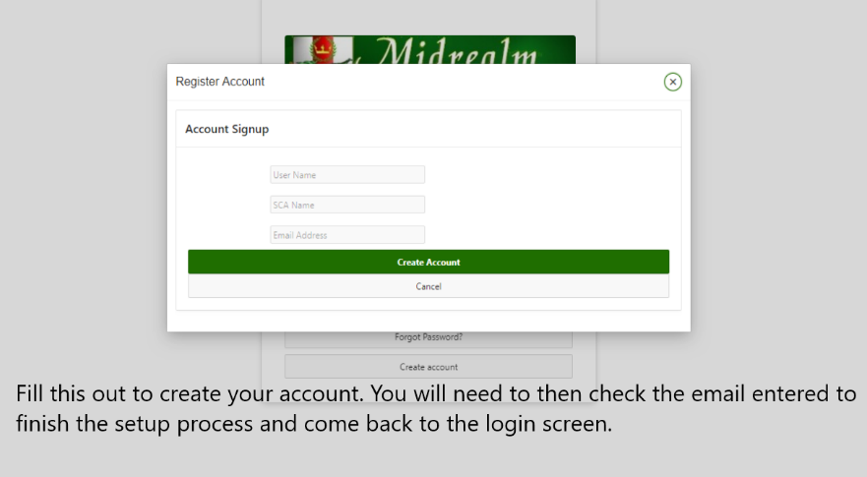
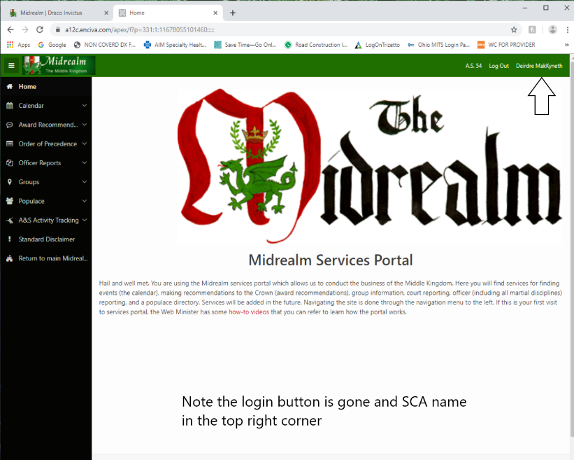 | 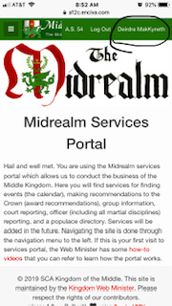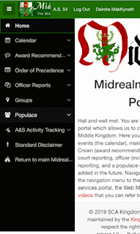
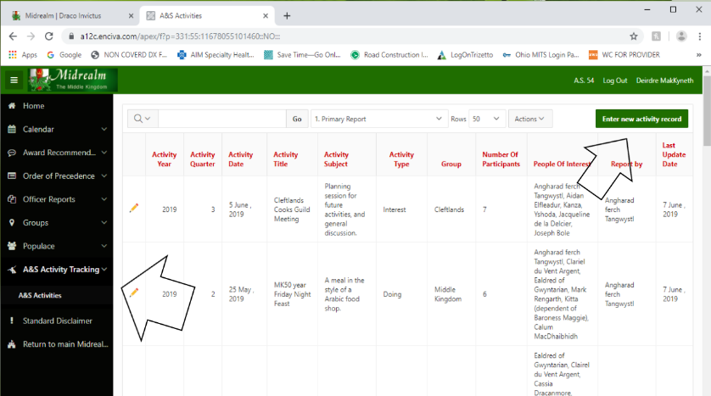 | 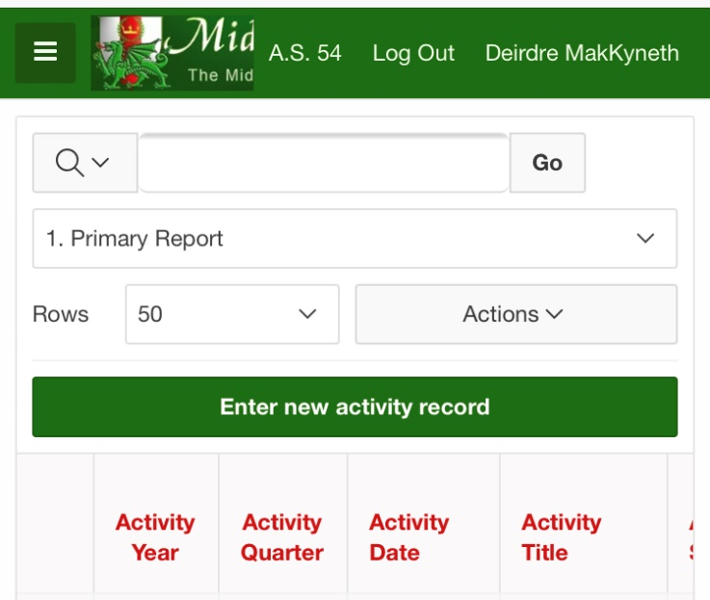
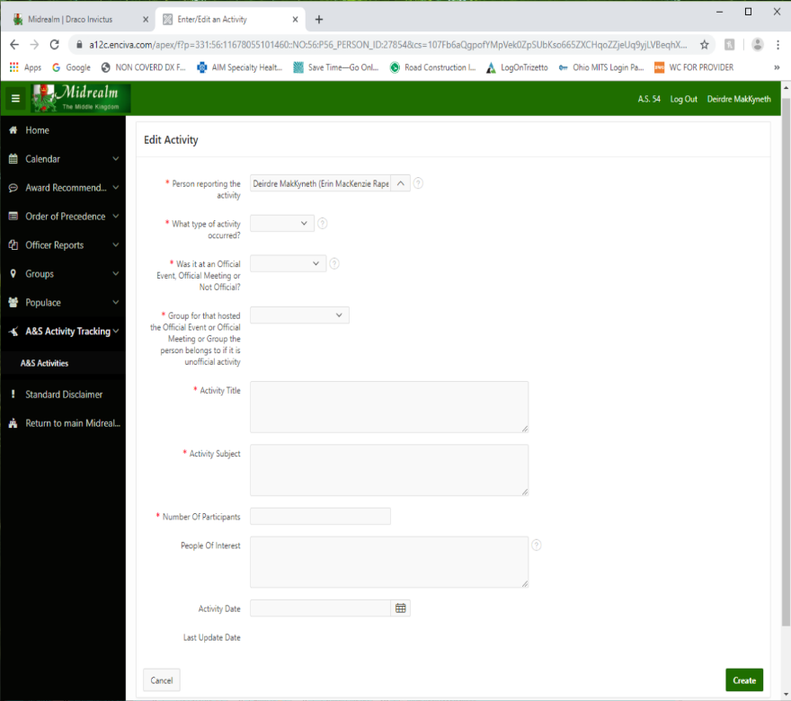 | 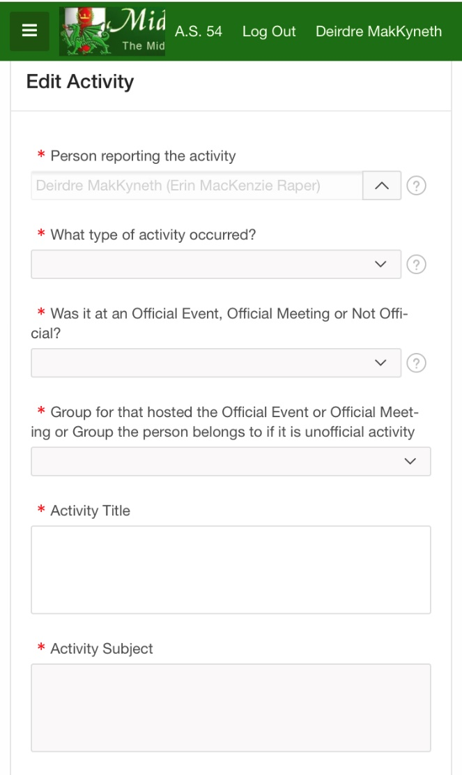

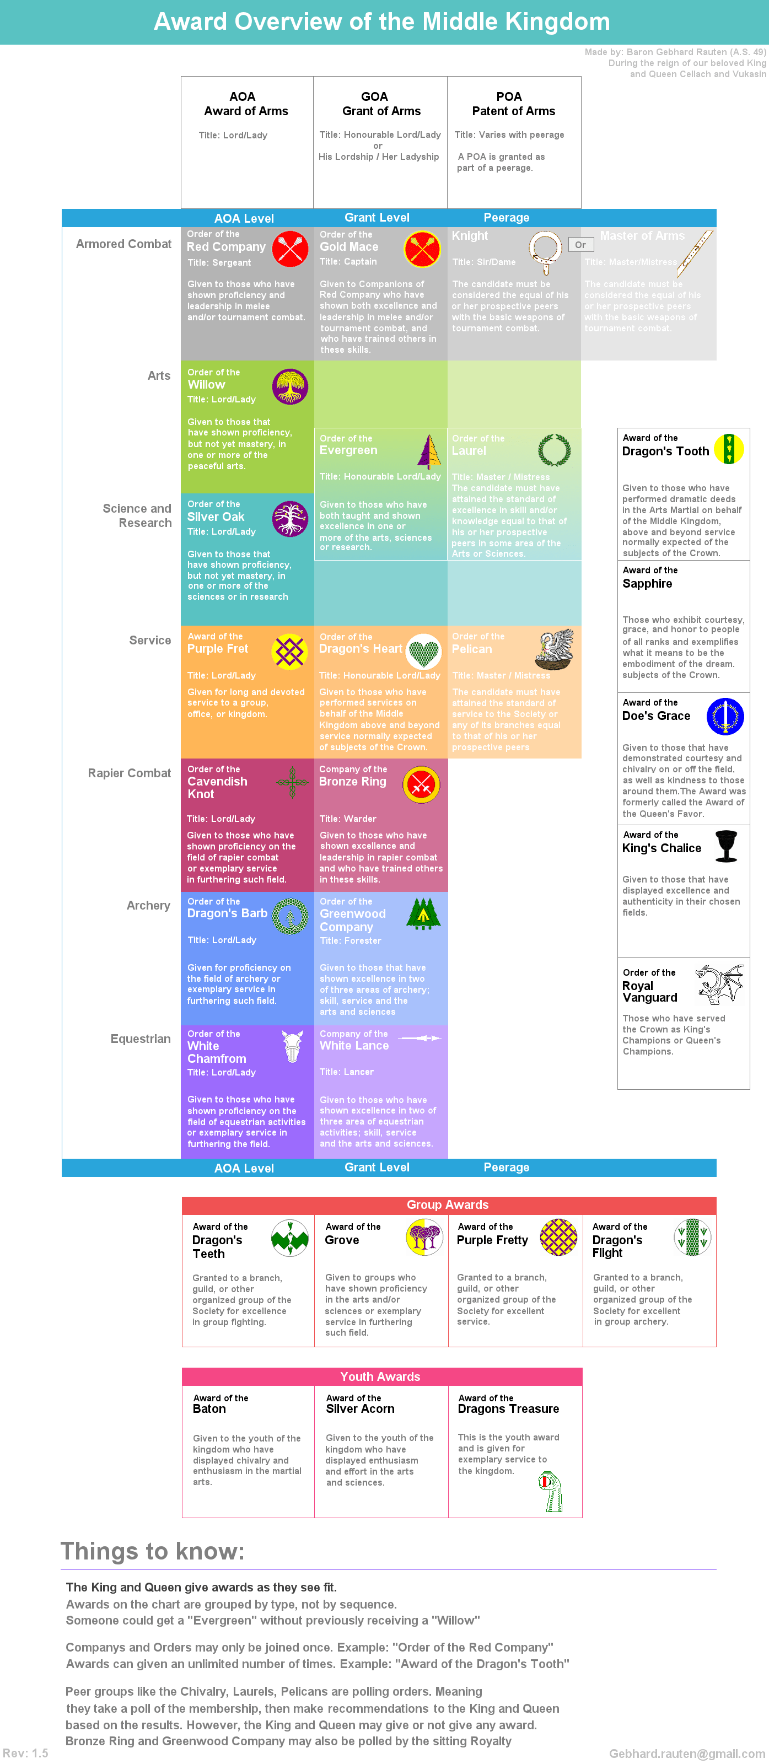
Award Recommendation
Midrealm.org and hover over “member resources”
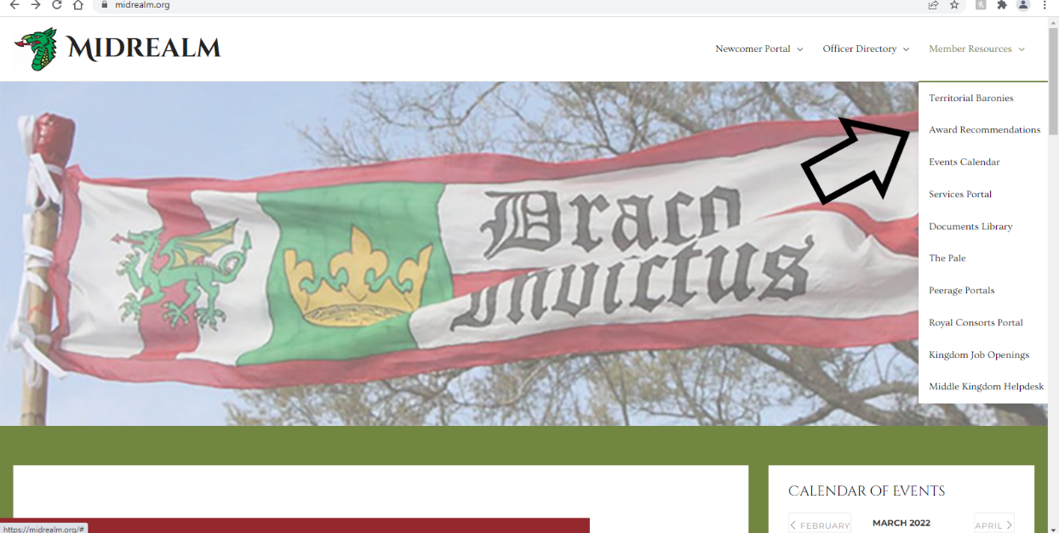

OFFICER REPORTS
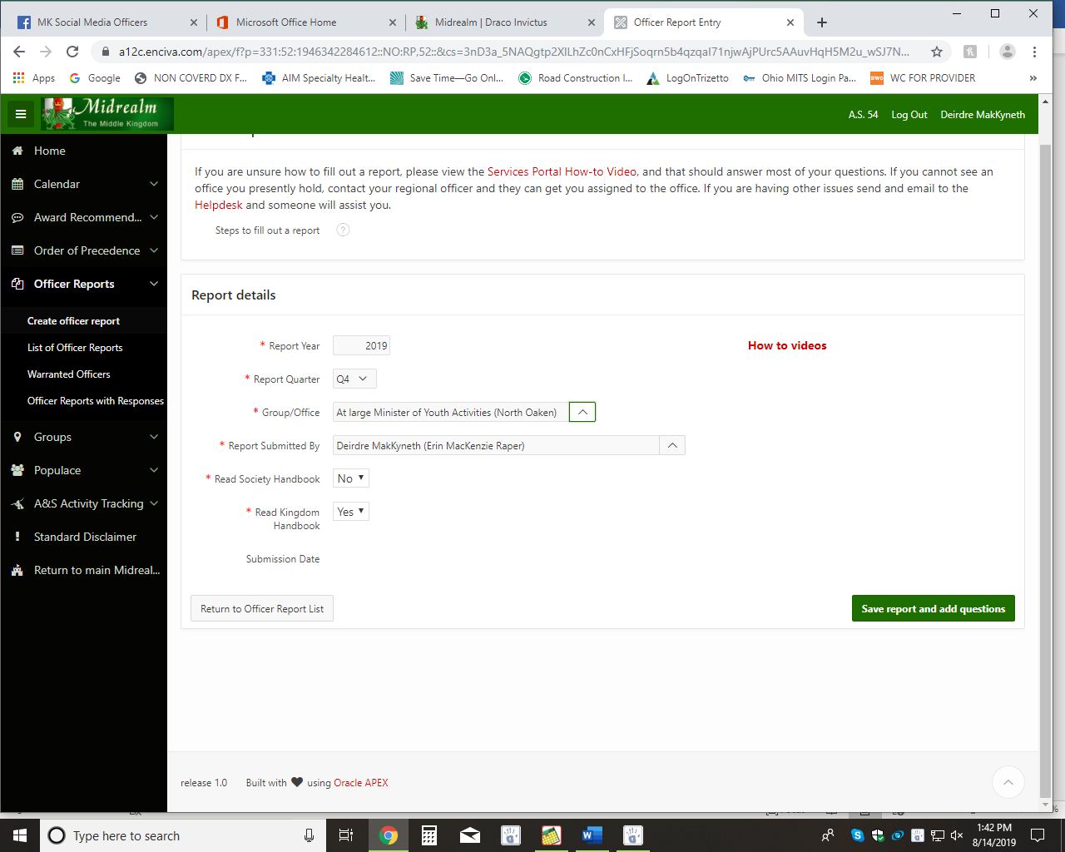

Q&A/NOTES

