Roots: The History of the SCA/Middle Kingdom/Barony Brendoken

The Middle Kingdom: The Midrealm, is the third oldest kingdom in the Society for Creative Anachronism (SCA).
http://www.midrealm.org/

Society for Creative Anachronism
https://en.wikipedia.org/wiki/Society_for_Creative_Anachronism

MiddleWiki: Encyclopedia, Glossary, and FAQ for the Middle Kingdom of the SCA http://middlewiki.midrealm.org/index.php/Main_Page

Office of the Cartographer: Herein you will find maps depicting the official boundaries of cantons, shires, provinces, baronies, and regions of the Middle Kingdom.
http://www.midrealm.org/cartography/

Barony Brendoken: Brief overview of the barony

http://middlewiki.midrealm.org/index.php/Brendoken

In the map below, Flaming Gryphon and Fenix choose to remain part of South Oaken.
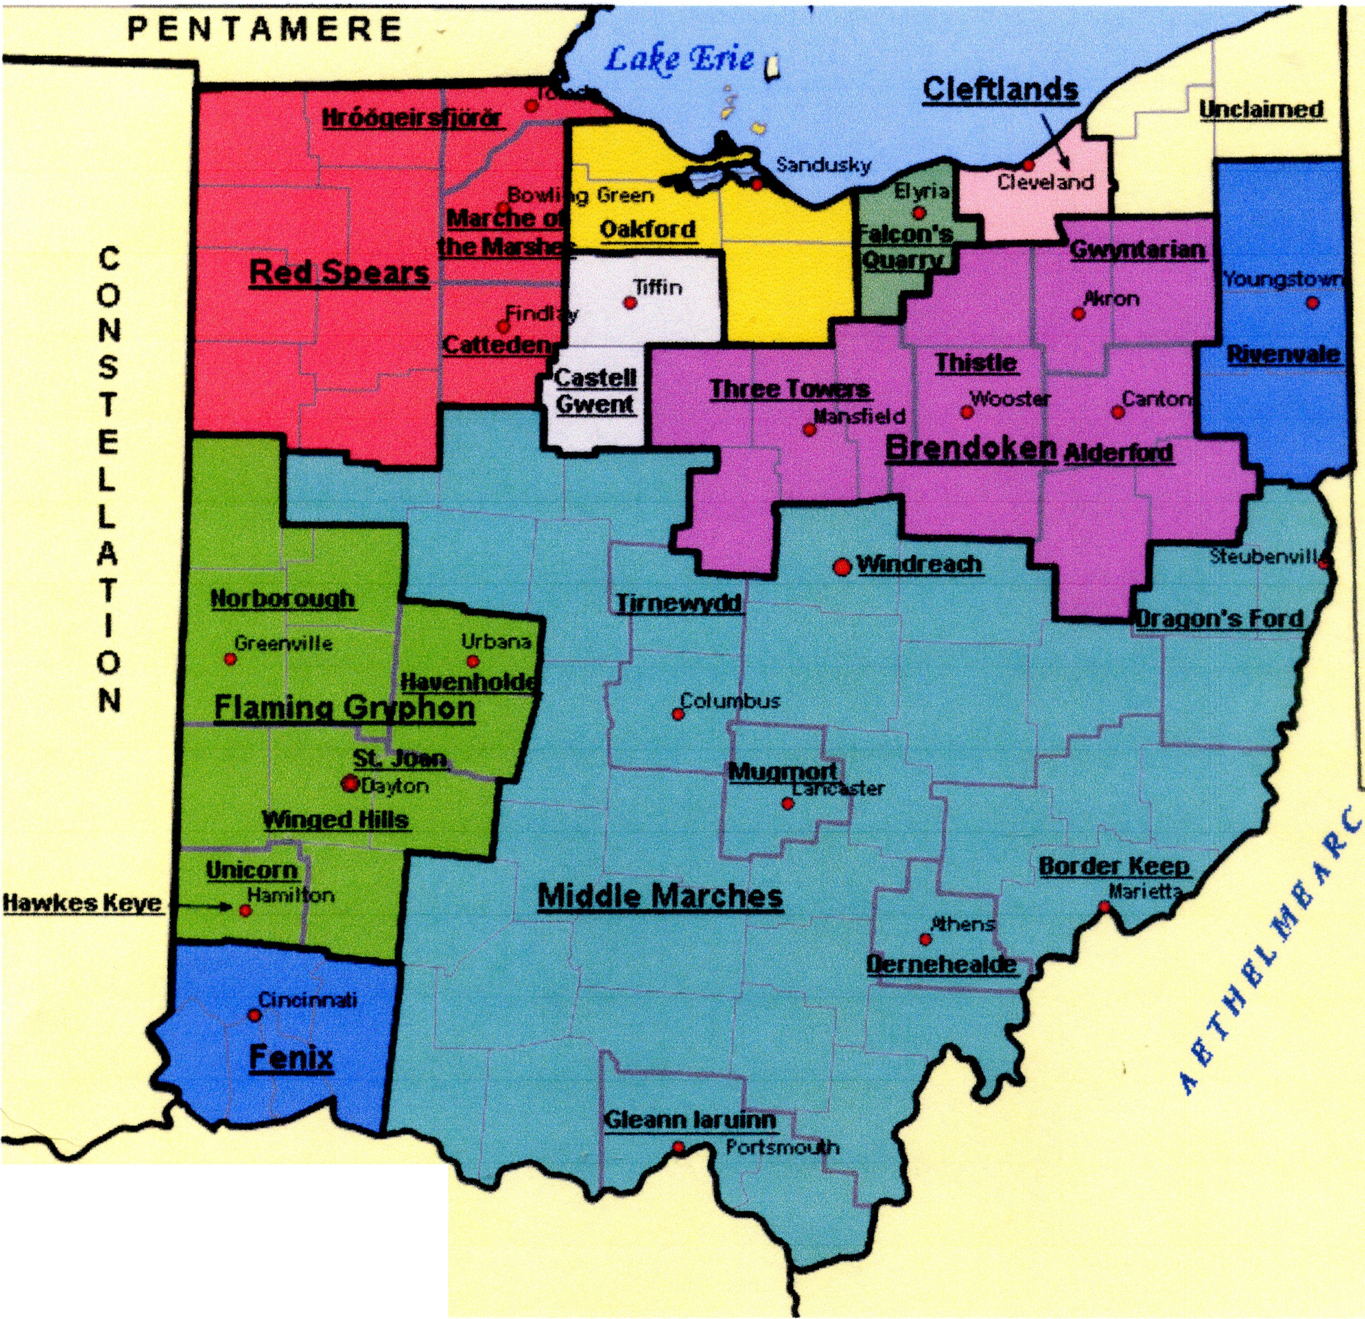
OAKEN

